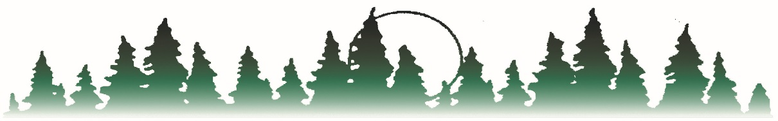
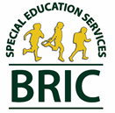

BEMIDJI REGIONAL INTERDISTRICT COUNCIL
Bagley PO Box 974 Kelliher
Blackduck Bemidji, MN 56619 Lake of the Woods
Cass Lake-Bena Phone 218-751-6622 Laporte
Clearbrook-Gonvick Brenda R. Story, Executive Director Littlefork - Big Falls
Mahnomen FAX Number 218-751-6625 Waubun-Ogema
Northome-Indus www.bric-k12.com Admin Office-Bemidji

Documentation of ADHD Diagnosis Form

Date of request:

Request sent to: at

Please provide the information requested below and return this document at your earliest convenience in the envelope provided. Authorization to Release Information included.

Student Name: Date of Birth:
(mm/dd/yyyy)
Diagnoses:

Prescribed Treatment Plan:

Additional Comments:

Signature of Licensed Physician, Mental Health or Medical Professional licensed to diagnose the condition:

Date

Thank you for your timely response!
Respectfully,

