March 2021
When to write a Prior Written Notice (PWN)
- When a student moves to your district with an active IEP you must review the file and then accept the IEP using a PWN and document any changes you’re making.
  - If the student is coming from out of state, be sure to have your School Psychologist review the Evaluation Report to ensure they meet MN Criteria for special education
    - If the student does not meet MN criteria, PWN would state that the district will provide comparable services until an initial evaluation is completed
- After any IEP team meeting; even if you don’t change the IEP. This documents the meeting and the discussion.
- A change in special education services from distance learning to in-person instruction per parent(s) request. See sample PWN
- Our legal counsel continually tells us that the PWN is the most important document in our due process forms. Make sure you take notes during your meetings and fill it out concisely to record the proposals and other options the team considered.

NOTE: Previously we asked case managers to write a PWN when students left the district. This is not required and we are no longer asking you to do this. Just be sure to go into Sped Forms and in the Setup page choose an exit reason, exit date, and inactivate them.

Progress Reporting:
Two consecutive insufficient progress reports triggers an IEP meeting. When a student is not making adequate progress, it is essential that we schedule a team meeting and consider alternatives to programming that would help them make adequate progress. Please notify & invite your Supervisor to your meeting to review and revise the IEP to discuss alternatives which may better meet the student’s needs.

Early Fall Due Dates
Any IEP or Reevaluation that is due before October 15th, 2021, needs to be completed this spring.

Child Find
There are NO cut-off dates for evaluations. Our responsibility to identify and evaluate students with a suspected disability never ends, so we cannot tell TAT/SST/MTSS teams that we “stop” evaluating in the spring.

Required Team Members
It’s important to remember that while we are having virtual IEP or ER meetings, we are still responsible for having the required team members in attendance. Required IEP Team members are:
- Student (anytime, but required in grade 9 and beyond)
- Parent/guardian
- General Education Teacher
- District Administrator
- Licensed Special Education Teacher in area of disability
If the required members cannot attend, you must get an excusal form signed by the parent and the absent team member must report their information to the parent in writing PRIOR to the meeting by giving it to the case manager.
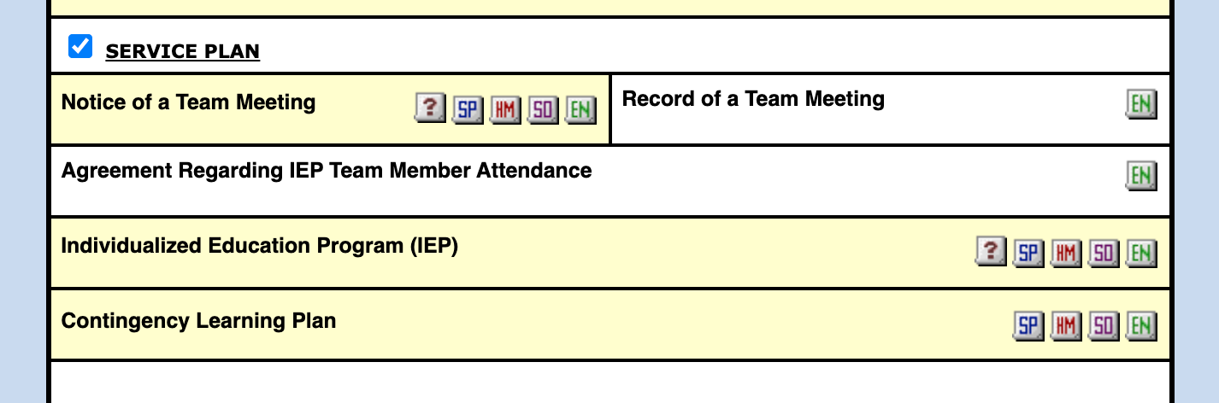

ESY Documentation Due Date - April 1st
Send all completed ESY forms to your BRIC Supervisor by April 1st.
Reminder: students who are graduating from high school are not eligible for ESY.

4th Quarter Progress Reports for Seniors = SOP
“What’s an SOP?” you may be asking. An SOP is a Summary of Performance. This form must be completed for all students who are graduating from high school and moving on to post-secondary life. The form is located under the Dismissal heading on the student’s forms menu page in SPED Forms.

Current status / progress data on goals and objectives can be reported in the academic and functional performance sections of this form and then it can serve as the final progress report for the student. Don’t forget to finalize!

