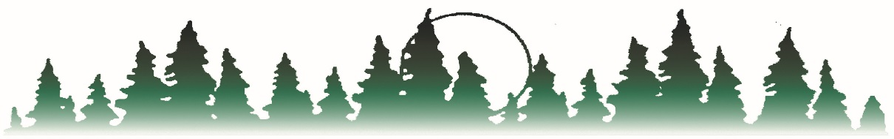
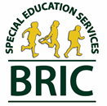

BEMIDJI REGIONAL INTERDISTRICT COUNCIL
Bagley PO Box 974 Kelliher
Blackduck Bemidji, MN 56619 Lake of the Woods
Cass Lake-Bena Phone 218-751-6622 Laporte
Clearbrook-Gonvick Brenda R. Story, Executive Director Littlefork - Big Falls
Mahnomen FAX Number 218-751-6625 Waubun-Ogema
Northome-Indus www.bric-k12.com Admin Office-Bemidji

Regional Grants
Special Education Necessity Form
All regional grant purchases requiring the use of federal special education funds (Regional Low Incidence-421, Regional CSPD-432 and Regional ECSE CoE-430/446) must be approved by the Regional Low Incidence Facilitator or the Regional ECSE Facilitator and the ISD 0998-52 Special Education Director in writing before any expenditure is made.
For expenditures not requiring a requisition (Consultant Services / Staff Development / Other Miscellaneous), this form must be completed and attached to the Consultant Contract, the Staff Development Request and/or other miscellaneous expenditures not requiring a requisition.

GRANT FINANCE NUMBER:

HOW DOES THIS EXPENDITURE PROMOTE THE OBJECTIVES OF THE GRANT LISTED ABOVE:

